CURRICULUM VITAE

1. Full name: Ali Ahmed Abdulkareem:
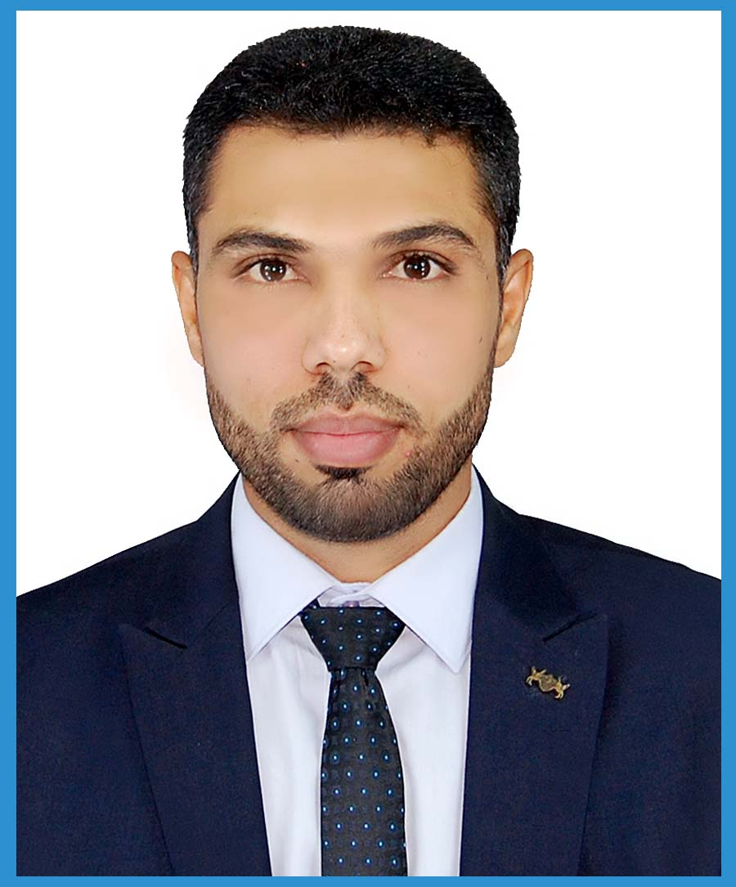
a. Family name: Aal- Banhaji
b. Name: Ali
c. Father: Ahmed
2. Nationality: Iraqi
3. Religion: Muslim
4. Sex: Male
5. Marital status: Married
6. Date of birth: 3/3/1983
7. Place of birth: Thi Qar, Iraq
8. Passport №: A 13104875, Date of Issue: 24/4/2018, Date of Expiry: 23/4/2026.
9. Weight: 65 Kg
10. Permanent Address: IRAQ
11. Present Address: Thi- Qar/ Soq Alshiyookh.
a. Head of Animal Production Department, College of Agriculture, Univ. of Thi- Qar, Thi- Qar City, IRAQ.
b. Telephone: Home Phone: ++964-7817230488.
c. E-Mail: alialamery83@yahoo.com- alialamery83@gmail.com.
12. Professional Experience
1. Assistant lecturer 1. 10. 2009, Animal Production Dept., Coll. of Agriculture, Univ. of Basrah, Iraq.
2. Assistant lecturer 6. 11. 2013, Animal Production Dept., Coll. ofAgriculture, Univ. of Thi- Qar, Iraq.
3- lecturer 16. 1. 2015 Animal Production Dept., Coll. Of Agriculture, Univ. of Thi- Qar, Iraq.
4- Assistant Professor 15. 1. 2020 Animal Production Dept., Coll. Of Agriculture, Univ. of Thi- Qar, Iraq.
13. Academic Qualifications:

 | Degree obtained | year | Average | Institution
1. | Baccalaureate (Scientific Section) | 2002 | 85 % | Soq Alsheyukh Secondary School, Thi Qar, IRAQ.
2. | B. Sc. In Animal Production | 2005 | 79 % | Agriculture College, Basrah Univ., IRAQ. *
3. | M. Sc. Poultry Nutrition | 2009 | 80 % | Agriculture College, Basrah Univ., IRAQ.
4. | P. H. D Molecular Genetics | 2015 | 85% | Agriculture College, Basrah Univ., IRAQ &  King's College London, Guy's Hospital, *
*: I got the first grade on my college.
*: I received joint supervision as part of the Scholarship Program at the UK / London/ Kings College London , the Molecular Oncology Unit, Gay's and Thomas' Hospital. My project involved the molecular analysis of the Gene Expression.

14. LANGUAGES

Arabic | Speaking very good | Reading very good | Writing very good
English | Speaking very good | Reading very good | Writing very good
Computer Skills | MS Excel, MS Word, access , power point, statistical (SPSS and Minitab,  Stat graphics)
15. Duties:
1- Director of Animal Research Station, Agriculture College, Basrah Univ., Iraq (from 2009 to 2011).
2- Technician in Oncology Unit, Medical College, Thi Qar Univ., Iraq (from 2015 till now).
3- Head of department of animal production since (from 2015 to 2019)
4- Director of Animal Research Station, Agriculture College, Thi Qar Univ., Iraq (from 2018 till now).
16. Honors and knowledge:
- From Dean of Agriculture, Basrah University. IRAQ., 2009
- From Dean of Agriculture, Basrah University. IRAQ., 2009
- From Dean of Agriculture, Basrah University. IRAQ., 2010
- From Dean of Agriculture, Basrah University. IRAQ., 2010
- From Dean of Agriculture, Basrah University. IRAQ., 2010
- From assistance of Dean , Agriculture, Basrah University. IRAQ., 2010.
- From my university president, Basrah university, Iraq, 2010.
- From my university president, Basrah university, Iraq, 2011.
- From my university president, Thi Qar university, Iraq, 2015.
- From my university president, Thi Qar university, Iraq, 2016.
- From my university president, Thi Qar university, Iraq, 2016.
- From my university president, Thi Qar university, Iraq, 2017.
- From my university president, Thi Qar university, Iraq, 2017.
- From my university president, Thi Qar university, Iraq, 2017.
- From my university president, Thi Qar university, Iraq, 2017.
- From my university president, Thi Qar university, Iraq, 2018.
- From my university president, Thi Qar university, Iraq, 2018.
- From my university president, Thi Qar university, Iraq, 2018.
- From my university president, Thi Qar university, Iraq, 2018.
- From my university president, Thi Qar university, Iraq, 2018.
- From my university president, Thi Qar university, Iraq, 2018.
- Minister of Higher Education and Scientific Research ,Iraq, 2018.
- From my university president, Thi Qar university ,Iraq, 2019.
- From my university president, Thi Qar university ,Iraq, 2019.
- From my university president, Thi Qar university ,Iraq, 2019.
- Minister of Higher Education and Scientific Research ,Iraq, 2021.
17- List of Publications:
- Jaffer M. Jassim; Abdullah, A. and Ali A. Abdulkareem. 2010.Effect of using enzyme mixture (protease, xylanase, amlyse) on Digestion coefficient and production performance of broiler.
- Ali A. Abdulkareem. 2009. The effect of using enzyme mixture (AVIZYME 1500) on the concentration of Blood Protein and Cholesterol and on the Productive performance of Broiler Chick. My Thesis.
- Ali A. Abdulkareem. 2015. Gene Expression and mRNA Abundance of Nutrients Transporter Genes in The Small Intestine of Broiler of Different Levels of Protein and Energy in Diets. My Thesis.
- Ali A. Abdulkareem; Asaad Y. Ayid and Abdullah A. Mohamed. 2015. Study mRNA Abundance and the Gene Expression Gene Expression of Protein Transporter Genes in The Small Intestine of Broiler of Different Levels of Protein and Energy in Diets.
- Ali A. Abdulkareem; Asaad Y. Ayid and Abdullah A. Mohamed. 2015. Study mRNA Abundance and the Gene Expression Gene Expression of Energy Transporter Genes in The Small Intestine of Broiler of Different Levels of Protein and Energy in Diets.
- Abdullah H. Salim; Ali A. Abdukareem. 2018. Effect of cytoplasmic inheritance in weights some muscle economic in goat.
- Abdullah H. Salim; Ali A. Abdukareem. 2019. CAST/ MSPI gene polymorphism and its impact on growth performance and carcass traits of shami gouts breed in Iraq.
- Ali A. Abdukareem. 2020.THE GENETIC VARIATIONS IN MITOCHONDRIAL D-LOOP SEQUENCE FOR LOCAL DUCKS IN IRAQ.
- Ali A. Abdukareem; Azhar Abdulabbas Jaffar and JAAFAR .M. OWAID. 2020. The relationship of the EAAT3 gene (Excitatory amino acid transporter 3) to the productive performance of broilers and the level of protein in the diet.

18. Participations:
- PCR techniques and their applications in agriculture, 2010, Molecular Genetics Lab., Animal production department, College of agriculture, Basra university, IRAQ
- The first Agricultural Conference, Basrah University, IRAQ.
- Work shop about the Iraqi Buffalo Animal Production Department, College of Agriculture, Basrah University, IRAQ.
- I have got invitation in the sixth international conference for Egyptian biological experimental, (27/2/2010).
- Certification of participation of training course for (Theoretical and Practical course: Genetic Applications in Human and Animal Health), held at the College of Agriculture, Basrah University, Iraq on behalf of the International center of Genetic Engineering and Biotechnology (ICGEB), 2011.
- Certification of participation of training course for (Theoretical and Practical Course: Polymerase Chain Reaction Techniques), held at College of Agriculture, Basrah University, Iraq, 2011.
- PCR techniques and their applications in agriculture, 2010, Molecular Genetics Lab., Animal production department, College of agriculture, Basra university, IRAQ.
- Attendance at the conference causes breast cancer and how to take due precautions, London, Guy's and Thomas' Hospital, The Molecular Oncology Unit.
- Certification of participation of the first Conference of agricultural research, held at College of Agriculture and Marshlands, Thi Qar University, Iraq, 2017.
- Certification of participation of the International Conference on Promotion of Scientific and Regional Cooperation on Food and Agricultural Sciences, held by Research Institute of food Science and Technology, Mashhad, Iran, 24th August 2018.
- Certification of participation of the scientific conference on the Breeding and Development of Buffalo. Ministry Of Agriculture, .2018
- Certification of participation of the Second Scientific Conference (ISC 2019) of the College of Science / Al-Qadisiyah University. Iraq, 2019.

